Department of Electrical Engineering

Faculty Member: Sir Habeel Ahmad Dated: 27-01-2026

Semester: BSCS-15 Section: D
Group No.:17

EE-221: Digital Logic Design
Lab 2: Introduction to Verilog

 |  | PLO4/CLO4 | PLO4/CLO4 | PLO5/CLO5 | PLO8/CLO6 | PLO9/CLO7
Name | Reg. No | Viva / Lab Performance | Analysis of data in Lab Report | Modern Tool Usage | Ethics and Safety | Individual and Team Work | Total marks Obtained
 |  | 5 Marks | 5 Marks | 5 Marks | 5 Marks | 5 Marks | 25 Marks
Fatima Haroon | 577112
Noor Fatima | 559891
Nehdia Rizvi | 540841
Zain Ahmad Irfan | 577280

Lab2: Introduction to Verilog, Gate-level/Behavioral Modeling and Hardware Implementation of Basic Logic Circuit

This Lab has been divided into two parts.

In first part you will be introduced to Verilog and Gate-Level Modeling.
The next part is the hardware implementation of a Boolean function given to you.

Objectives:
- Understand HDL and compare it with normal programming languages.
- Simulate Basic Gates using Verilog with ModelSim
- Write stimulus using Verilog
- Derive algebraic expression for a Boolean function from the given schematics.
- Hardware Implementation of Logic Circuit

Lab Instructions
- This lab activity comprises three parts, namely Pre-lab, Lab tasks, and Post-Lab Viva session.
- The lab report will be uploaded on LMS three days before scheduled lab date. The students will get hard copy of lab report, complete the Pre-lab task before coming to the lab and deposit it with teacher/lab engineer for necessary evaluation. Alternately each group to upload completed lab report on LMS for grading.
- The students failing to submit Pre-Lab will not be allowed to perform Lab work.
- The students will start lab task and demonstrate design steps separately for step-wise evaluation( course instructor/lab engineer will sign each step after ascertaining functional verification)
- Remember that a neat logic diagram with pins numbered coupled with nicely patched circuit will simplify trouble-shooting process.
- After the lab, students are expected to unwire the circuit and deposit back components before leaving.
- The students will complete lab task and submit complete report to Lab Engineer before leaving lab. Verilog tutorial part is non-printable and for reference only.
- There are related questions at the end of this activity. Give complete answers.

Pre-Lab Task: (To be done before coming to the lab) (2 marks)
- Read the manual Getting Started with Verilog and answer the following questions.
- HDL stands for?
- Hardware Description Languages and fall in the category of low-level programming languages.
- These languages describe hardware and define how a circuit should be built.
- It allows us to design and verify the electronic circuits before building the actual hardware.

- Two standard versions of HDL
Two standard versions of HDL (Hardware Description Languages) are VHDL and Verilog HDL.

- Explain different abstraction levels of Verilog
In Verilog we have different abstraction levels as follows:
- Gate Level Modeling
- Uses basic logic gates like AND, OR, NOT, etc.
- We connect gates together to build the whole circuit

- Dataflow Modeling
- Uses operators like +, -, &, |, etc.
- No need to connect gates manually
- Describes how data flows from input to output
3.Behavioral Modeling
- Describes what the system does, not how it is built
- Focuses on input–output behavior
4.Switch Level Modeling
- Works at transistor level
- Deals with switches
- Complex and detailed
- Only used in critical applications or part of a system

Lab Tasks: (8 marks)
Lab Task 1: (2 marks)
Model and simulate the basic gates i.e. NOT, AND & OR in Verilog (Gate level) using Modelsim. Compare the simulation waveform results with truth table in the space given below.
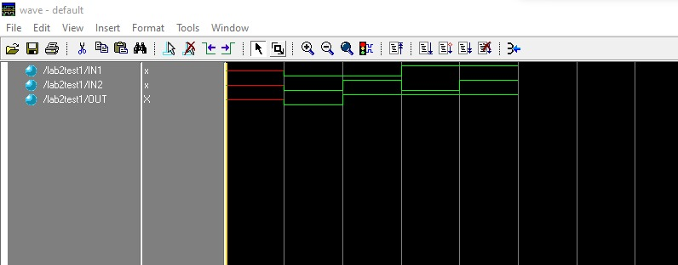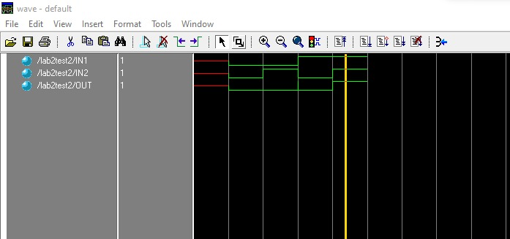

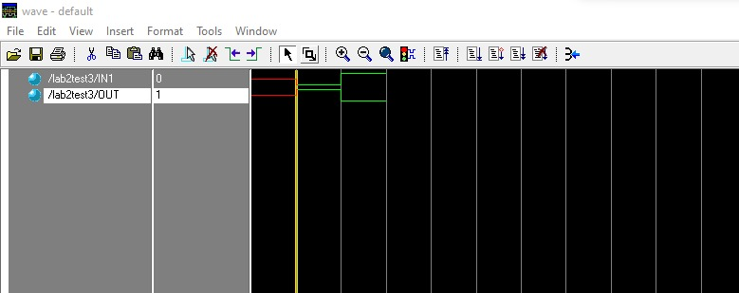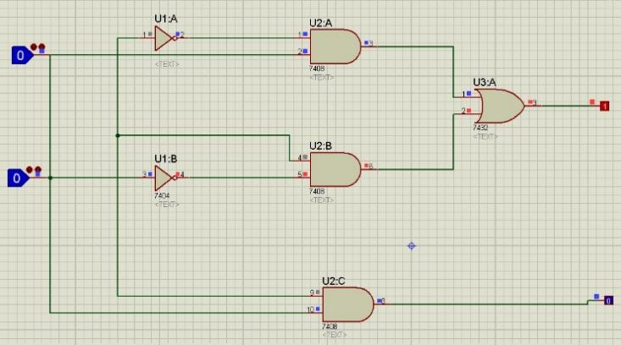

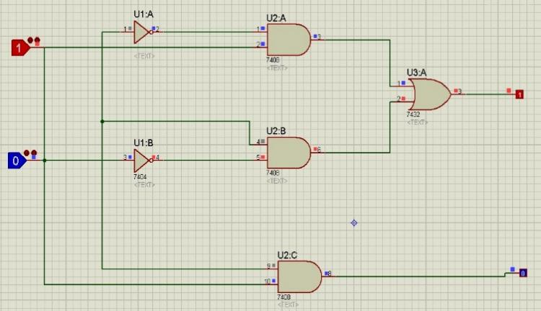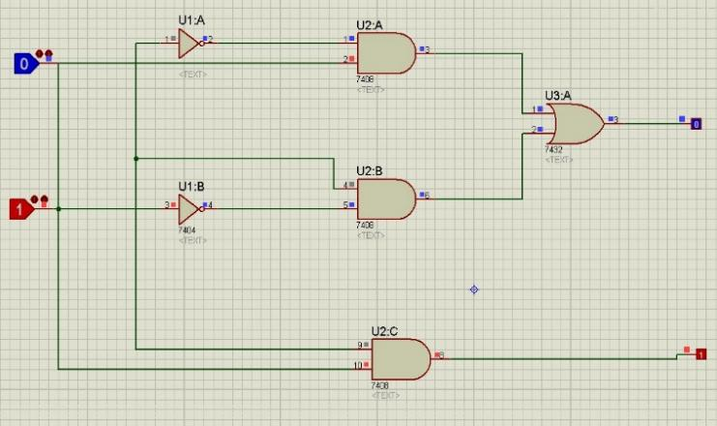
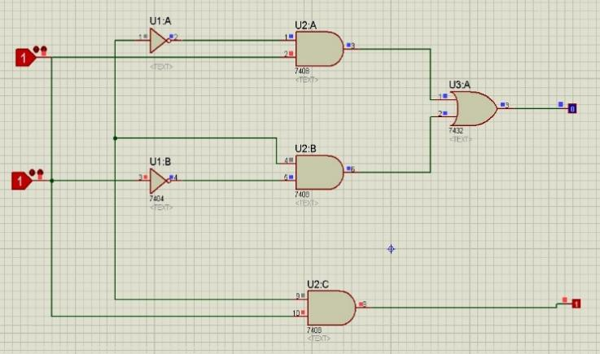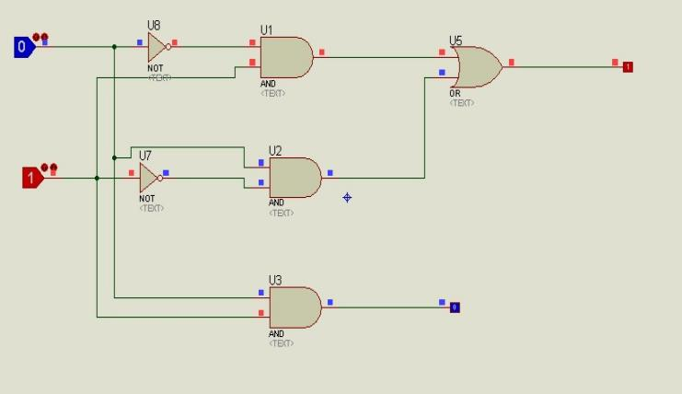

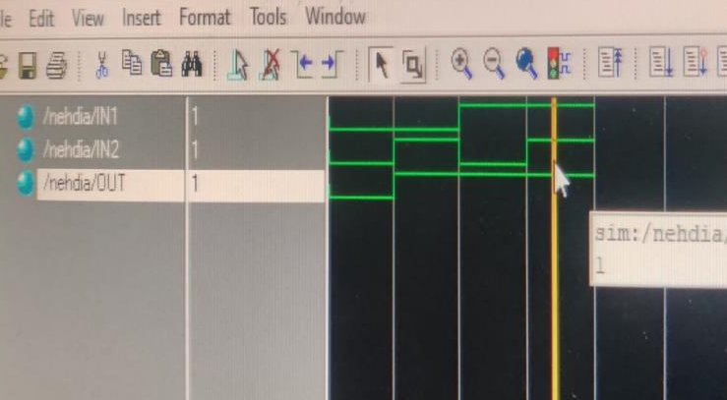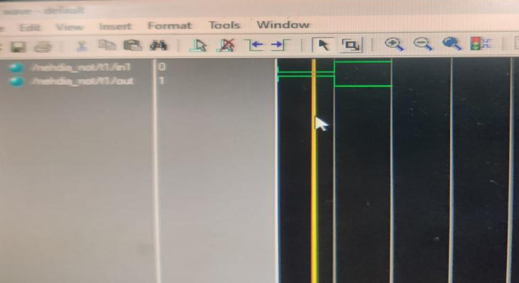

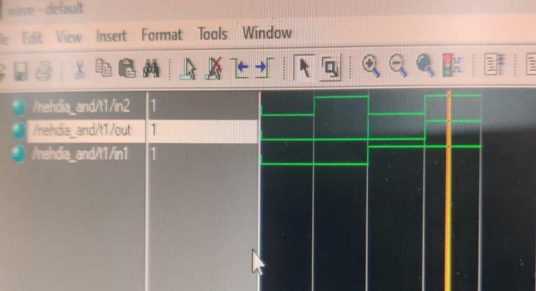
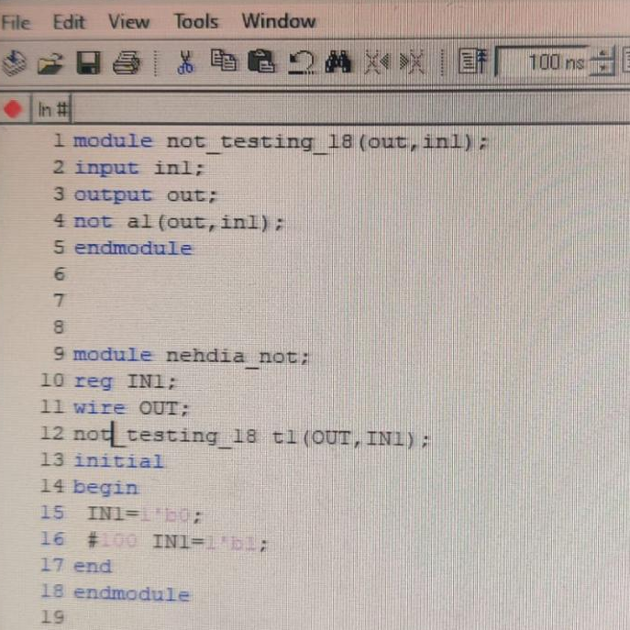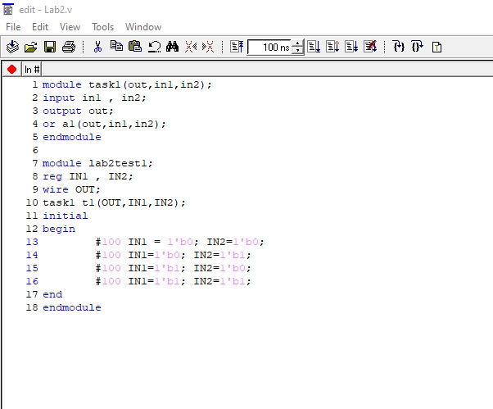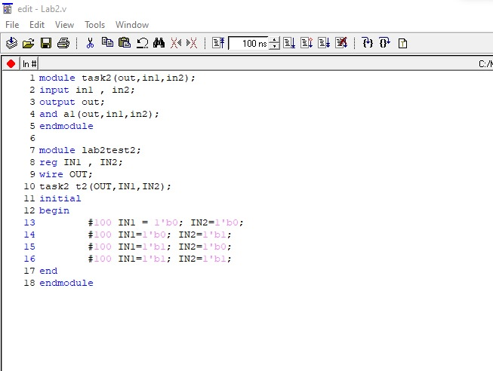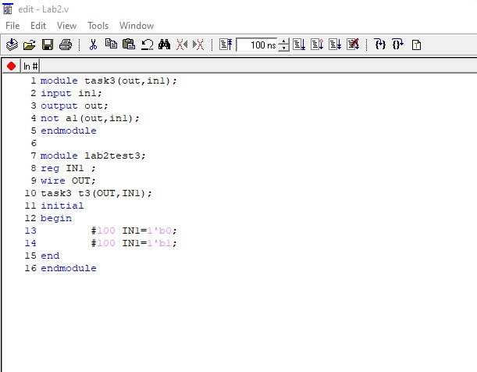

Lab Task 2: (2 marks)
Write the Verilog Code using Gate Level modeling for the following circuit. List the code for design as well as stimulus below:
Simulate below circuit on Proteus and perform it on hardware.

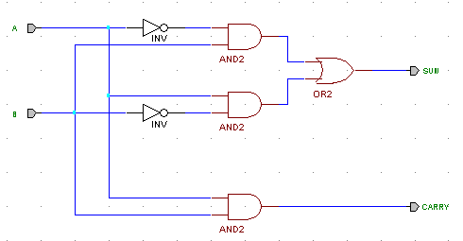
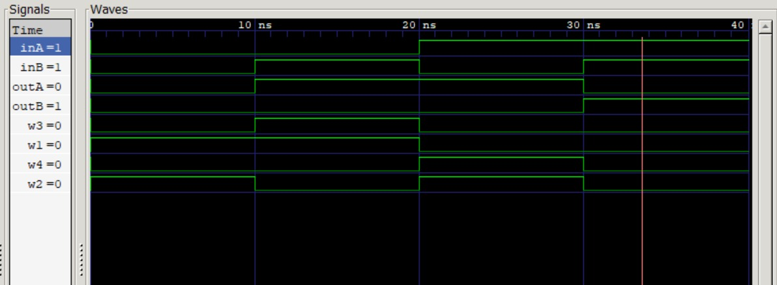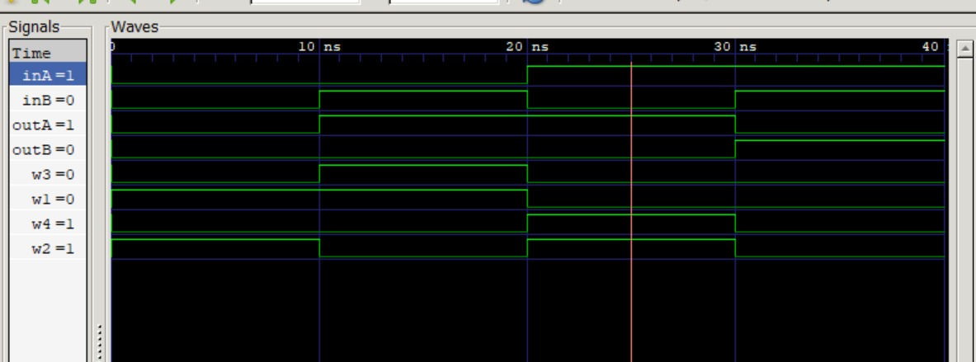
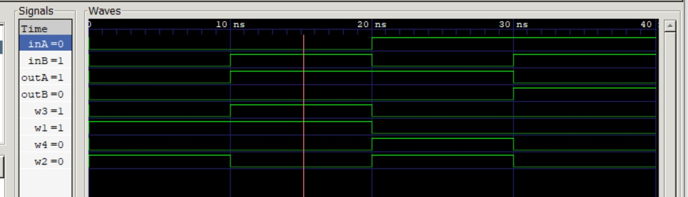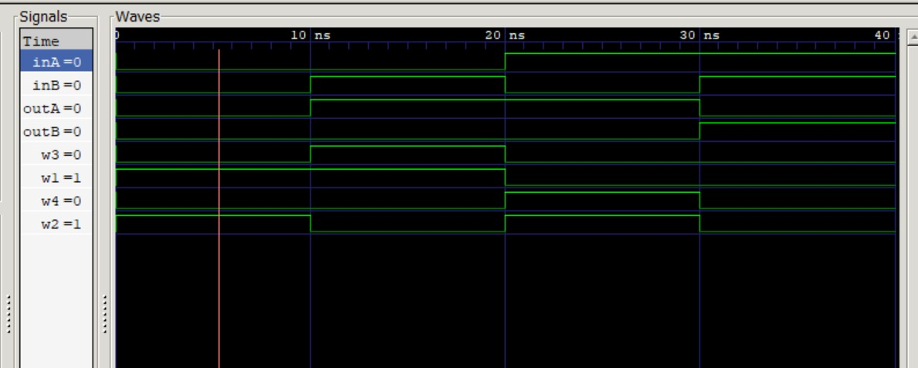
Code:
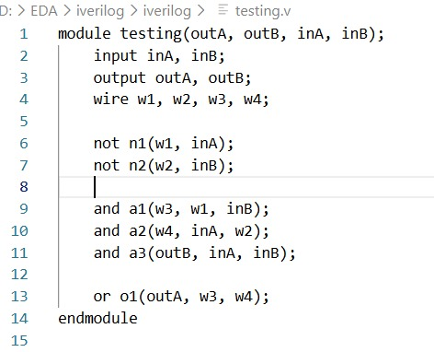
TestBench for stimulus:
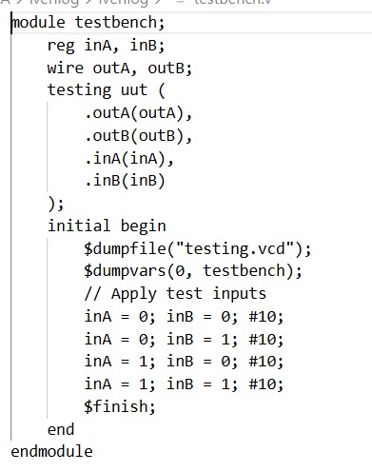

Lab Task 3: (2 marks)
Label each gate output in the above circuit and derive algebraic expressions for SUM and Carry Out. Fill in the following truth table and determine the function performed by the circuit.
Algebraic Expression:
SUM output: (~A & B) | (A & ~B)
CARRY output: (A & B)
Truth Table:
x | y | Sum | Carry Out
0 | 0 | 0 | 0
0 | 1 | 1 | 0
1 | 0 | 1 | 0
1 | 1 | 0 | 1

Function of Circuit:
The sum output provides result for xor function and the carry output provides result for AND function both using the same two inputs A and B at the same time.

Lab Task 4: (2 marks)
After determining the function performed by the circuit given in Lab Task 2, write the Verilog description of the circuit in dataflow. Comment on the two different modeling levels you used to model the same circuit. (Paste snapshots of the codes and stimuluses below)
Code:
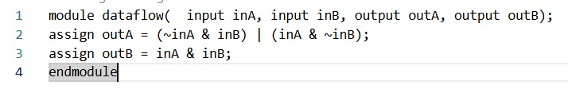
Stimulus Testbench:
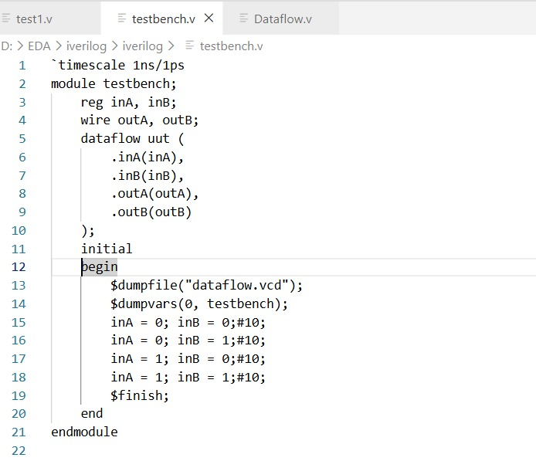
- In gate-level modeling, the circuit is implemented using individual logic gates such as AND, OR, XOR, and NOT. This approach closely matches the real hardware structure of the circuit. It helps in understanding the internal operation, but the design becomes difficult to manage as the circuit size increases.
- In dataflow modeling, the circuit is represented using Boolean equations with assign statements.
This method produces shorter, clearer, and easier-to-debug code.
It emphasizes the function of the circuit rather than the physical gate-by-gate implementation.
Observations/Comments:
- The simulation results were correct and matched the truth table.
- Gate-level modelling showed how the circuit is built using logic gates.
- Gate-level code was longer and harder to manage.
- Dataflow modelling was easier to write and understand.
- This lab helped in understanding Verilog and circuit simulation.

